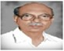
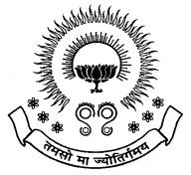
PBRVITS Alumni Association

ALUMNI ASSOCIATION CELL

AAC HANDBOOK

ALUMNI ASSOCIATION CELL

Objectives :
- Expanding & updating the database of ALUMNI.
- Providing the alumni the information about the programs & events conducted in college.
- To promote fellow feeling amongst ALUMNI.
- To bring together the ALUMNI of the college by arranging frequent meetings.
- To assist in campus recruitments, suitable placements & training for the students.
- Setup guidance cell to aid present & past students.

Alumni Meet
Every year an ALUMNI MEET is conducted to bring together the ALUMNI of the college.

Alumni Database
An alumni database has been maintained at present in which almost all the alumni have registered as life time members.

Alumni E-Group
Alumni e-Group has been created

Alumni Website

LIST OF MEMBERS
Name in block letter & s/o,W/o | Age | Designation | Occupation | Residential  Address | Signature
Vemula.V.Sunil Kumar  S/O Mala Kondrayudu | 33 | PRESIDENT | Associate Professor,PBRVITS,kavali | 9-27-31A  Om santhi street  Kavali-524201
Javangula.Vamsinath  S/O J.Venkata Narasimha Rao | 30 | VICE PRESIDENT | Associate Professor,PBRVITS,kavali | 3-8-22,  vishnalayam Street,  Kavali-524201
Chittimuri. Srinivasulu Reddy  S/O Ch.Venkata Rami Reddy | 34 | SECRETARY | Associate Professor,PBRVITS,kavali | 5-1-34A,old town,  Kavali-524201
K. Manoj Siva Kumar | 30 | JOINT  SECRETARY | AssistantProfessor  PBRVITS,kavali | 3-14-9  Boddukuri vari street,  Kavali-524201
Nosina. Krishna Chaithanya  S/O N.Seshaiah | 33 | TREASURER | Associate Professor  PBRVITS,kavali | 25-7-558,C-block, vengalarao nagar, dycus road,  Nellore-524004
Ch.V.S.Parameswara Rao  S/o Ch.Subba Rao | 48 | EXECUTIVE  MEMBER | PRINCIPAL  PBRVITS,kavali | Plot no-401,  Sai meadows,  Kavali
Vemuri.Phani Bhushan  S/O V.Subramanyam | 43 | EXECUTIVE  MEMBER | HOD,ECE Dept.  PBRVITS,kavali | 11-33-990/c  Balaji Street,  Vengala rao nagar  Kavali-524201
Bade.Konda Reddy  S/O B.Mala konda reddy | 38 | EXECUTIVE  MEMBER | HOD,Mechanical Dept  PBRVITS,kavali | 11-40  Near water tank,  Bapuji nagar,  Kavali-524201
Dodla.Srujan Chnadra Reddy  S/O D.Manohar Reddy | 38 | EXECUTIVE  MEMBER | HOD,CSE Dept.  PBRVITS,kavali | 4-14-38  Old town,  kavali

Signature of the President

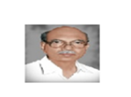
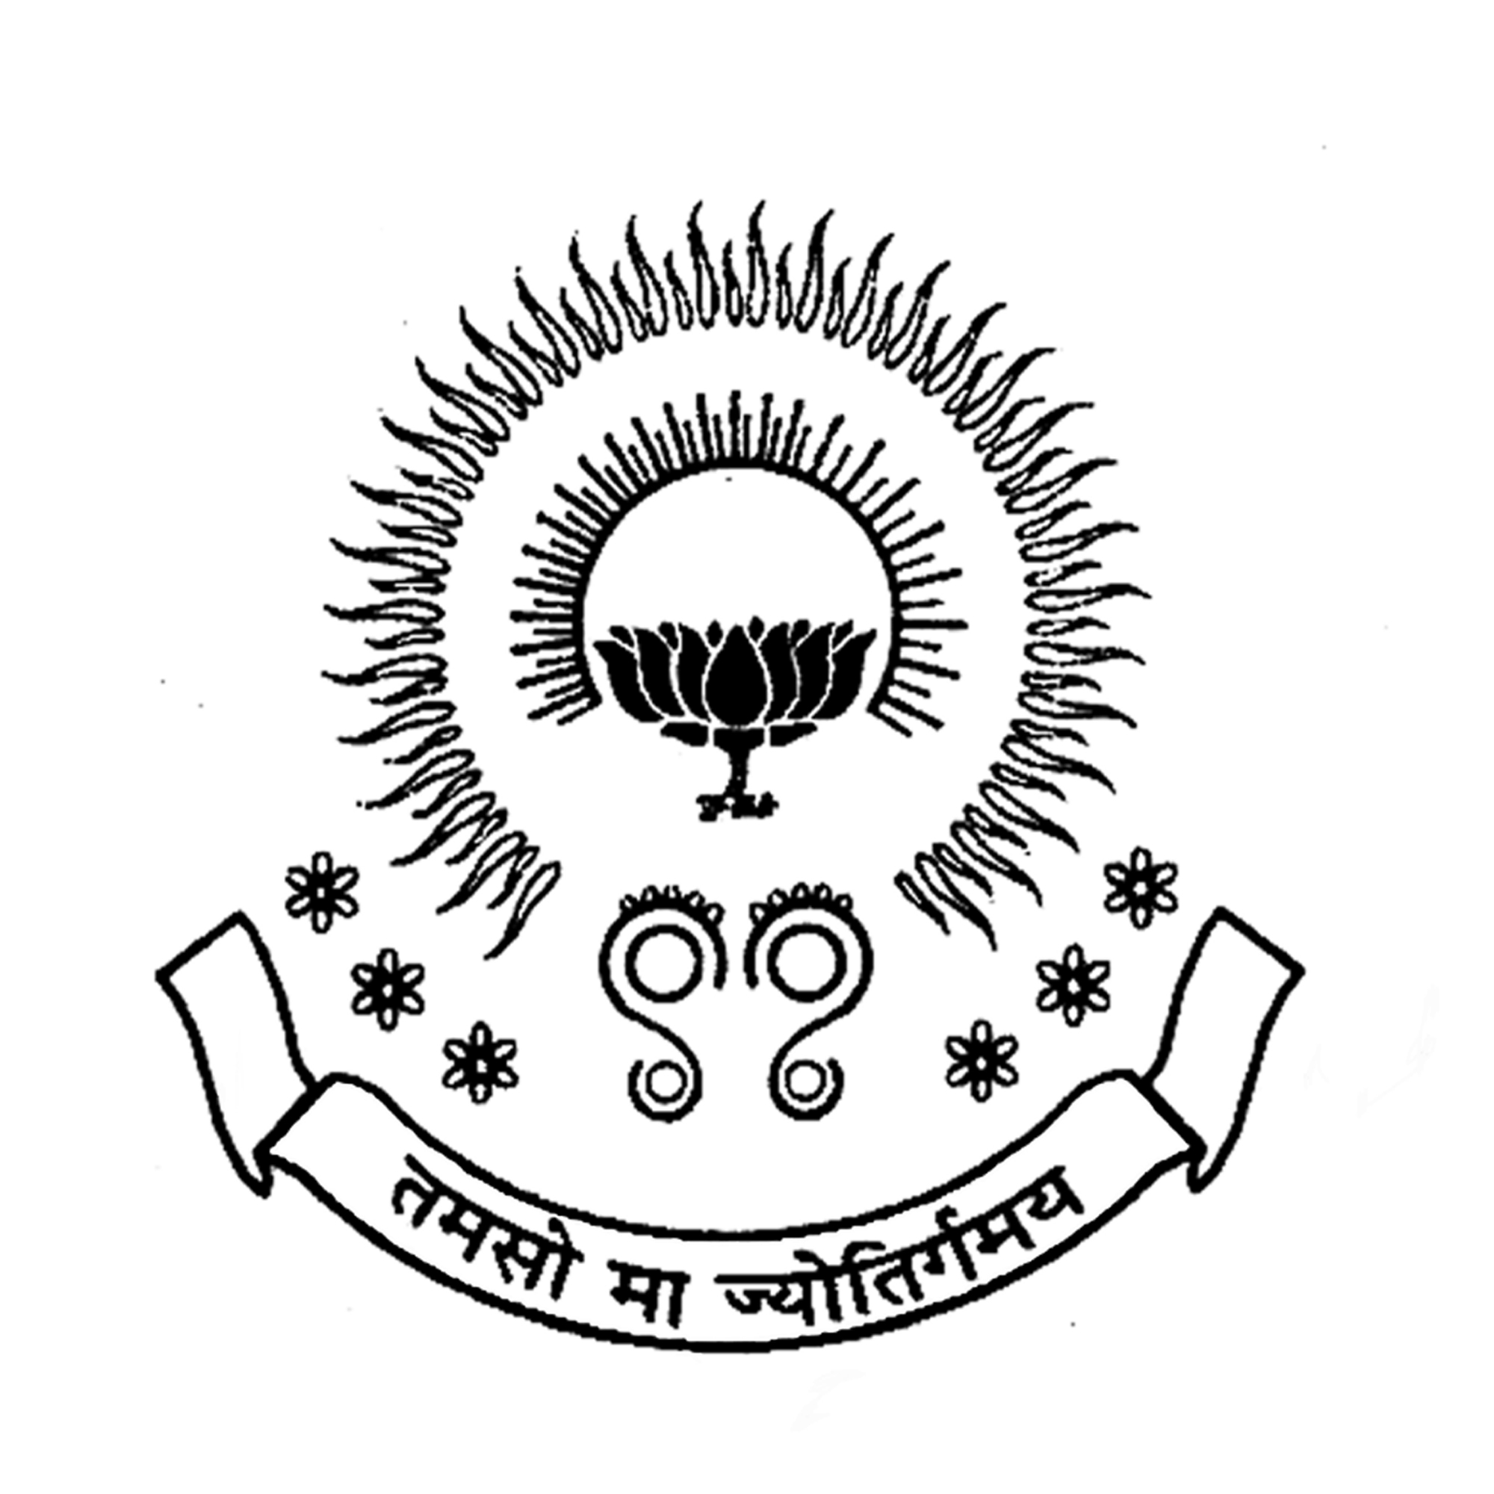
PBR VISVODAYA INSTITUTE OF TECHNOLOGY & SCIENCE
KAVALI
(Affiliated to J.N.T.U.A., Anantapuram and Approved by AICTE, New Delhi)

ALUMNI ASSOCIATION CELL

Minutes of Meeting
Date: 06-11-2018
Opening:
The regular meeting was called by the co-ordinator of AAC to order at 11.00 AM on 05-11-2018.
Present:
- V.V.Suneel Kumar ( President, AAC PBRVITS )
- J. Vamsinath( Vice President, AAC PBRVITS )
- Ch.Srinivasulu Reddy( Secretary, AAC PBRVITS )
- K.Manoj Siva Kumar( Joint Secretary, AAC PBRVITS )
- N.Krishna Chaithanya(Treasurer)
- Ch.V.S.Parameswaro Rao(Executive Member,AAC PBRVITS)

Agenda:
- The members of the AAC have finalized the date of Alumni meet on second Saturday of January 2019. i.e 12/01/2019 at 10.00 AM.
- Decided on Win Commander I.P.C Reddy to be the invitee.
- Committees were also formed for the smooth conduction of the Alumni meet .

Committee | Incharge | Duties
Stage | Sk.Shaheena Begum  A. Madhavarao  S.Penchal Naidu | Stage decoration, Anchoring
Reception | I.J Abhishita  Volunteer students | Guest receiving, Arrangements

Meeting was adjourned at 11.45 AM by V.V Suneel kumar.
AAC Co-ordinator

PROGRAM SCHEDULE OF ALUMNI MEET
Date: 12th January, 2019
Venue: Conference hall, PBR VITS.
Time | Program
10:00 A.M- 10.30 A.M | Welcome by prayer
10:30A.M-1:00 P.M | Lighting of the Inaugural program
 | Welcome Address by President, Chief guest, Principal, Treasure, Placement officer
 | Alumni Interaction
1:00 P.M -2:00 P.M | Lunch
2:00 P.M -3:00 P.M | Alumni Feedback
3:00 P.M -4:00 P.M | Awards distributions
4:00 P.M – 4:30 P.M | Vote of Thanks

STAGE MEMBERS
- Mr. V.V Suneel kumar, President
- Mr. Win Commander I.P.C Reddy, Chief Guest
- Ch.V.S.Parameswara Rao, Principal
- N.Krishna Chaithanya, Treasurer
- Mr. B. Vamsee Mohan ,Placement officer

- The program conducted successfully by 10:30 A.M with the grace presence of all dignitaries and Alumni students.

- Total 107 students attended the meet from various outstations, companies and with different profiles. In response, few of the alumni shared their experience as well as intresting moments of campus life to the audience.

- A delicious lunch was served for all the alumni members at the end of alumni reunion.

- Thank you one and all for being a part of the alumni Reconnect program. The occasion was successfully ended.

YEAR | Date of conduction | No. of Alumni’s Attended |  |  |  | TOTAL
 |  | CSE | ECE | EEE | ME
2015 | 09/01/2016 | 30 | 35 | 20 | 10 | 95
2016 | 14/01/2017 | 36 | 35 | 18 | 13 | 102
2017 | 13/01/2018 | 38 | 34 | 23 | 15 | 110
2018 | 12/01/2019 | 40 | 35 | 20 | 12 | 107
Summary Table

AAC Co-ordinator

Suggestions

- Social awareness programs to prevent increasing suicides, drugs & alcohol.
- Suggested to provide video lectures.

