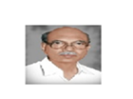
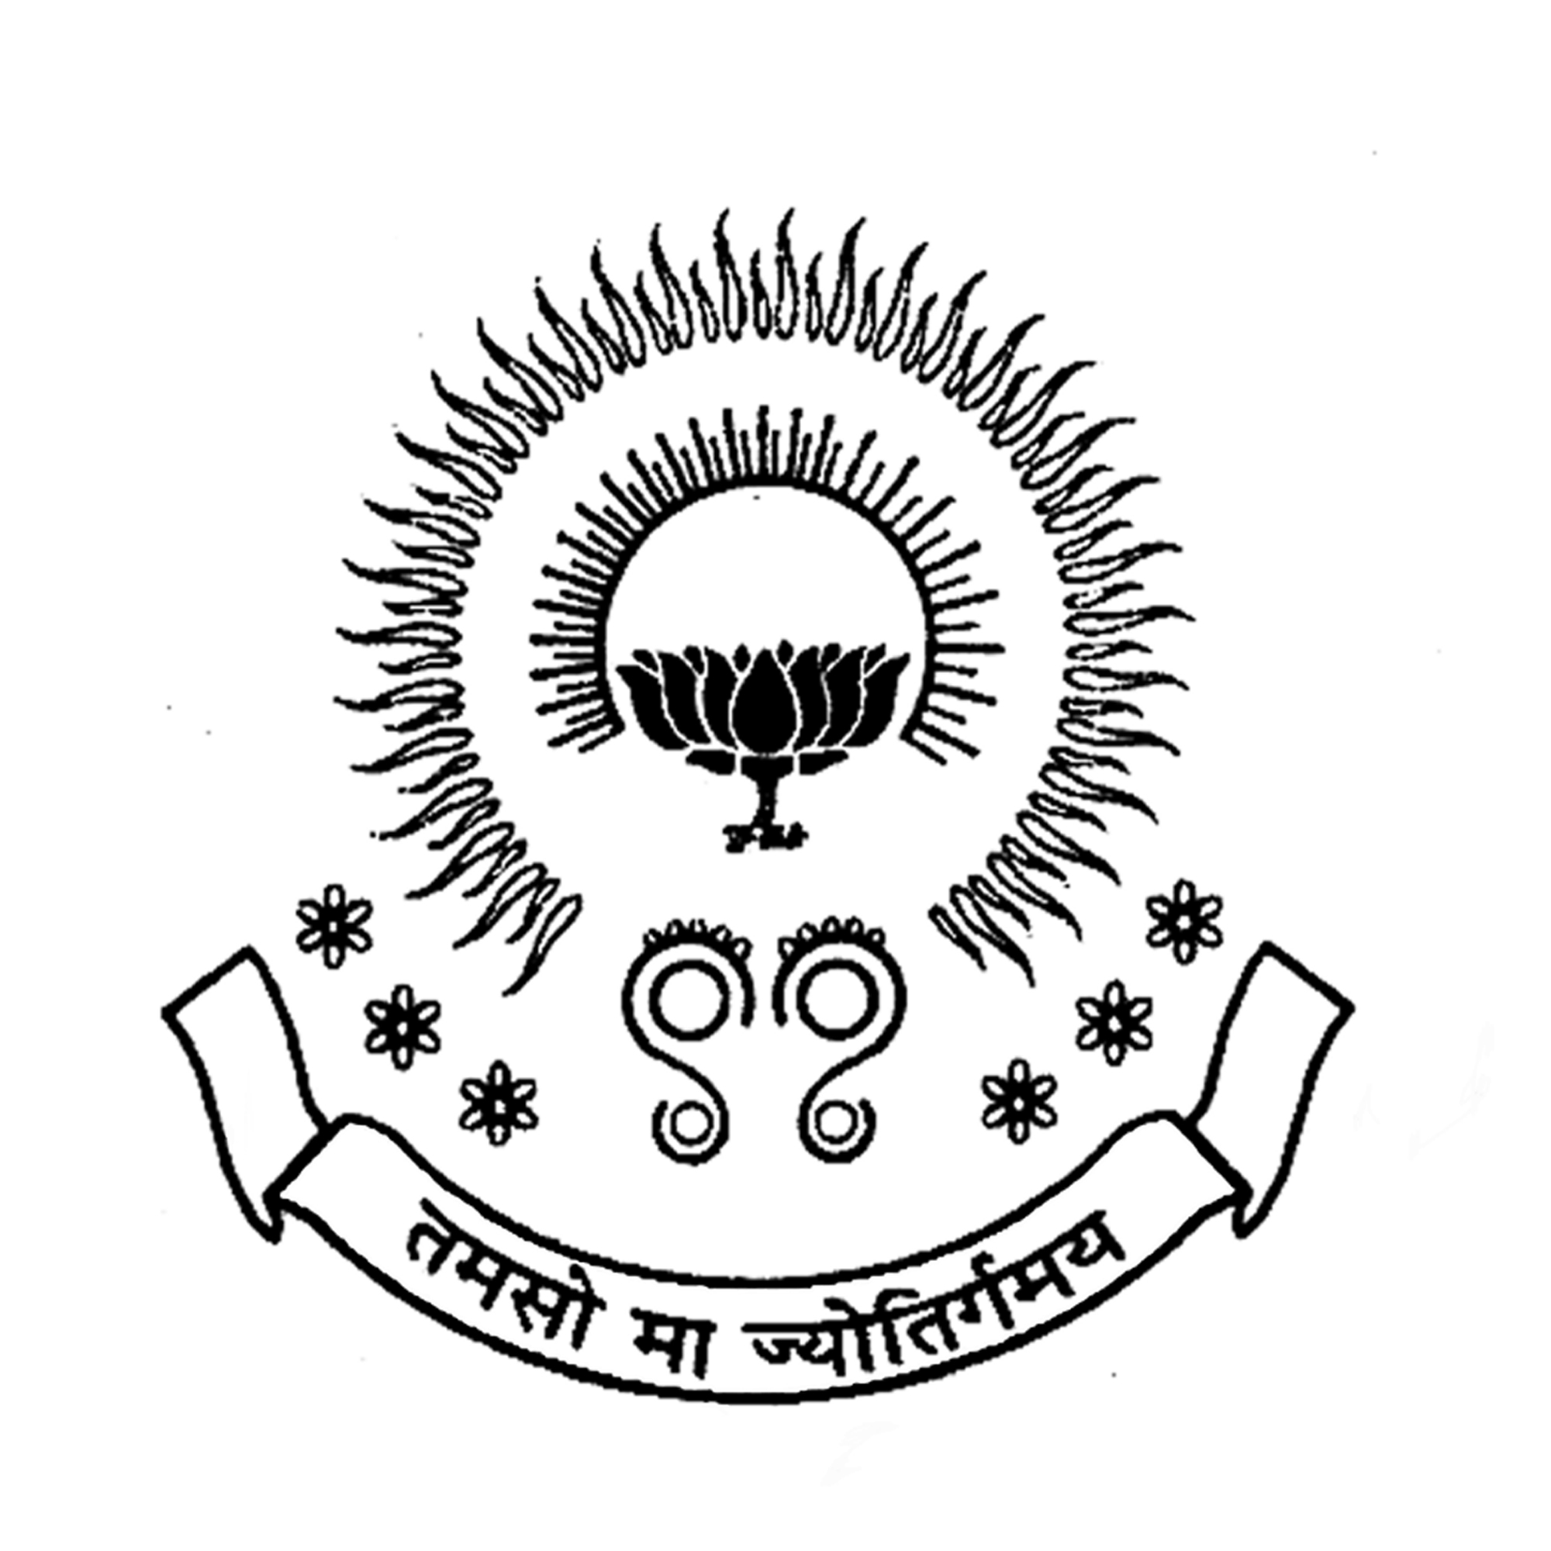
PBR VISVODAYA INSTITUTE OF TECHNOLOGY & SCIENCE
KAVALI
(Affiliated to J.N.T.U.A., Anantapuram and Approved by AICTE, New Delhi)

ALUMNI ASSOCIATION CELL

Minutes of Meeting
Date: 30-12-2021

Opening:
The regular meeting was conducted by the coordinator of Alumni Association Cell at 4.00 PM on 28-12-2021 through online via https://meet.google.com/cvz-seky-daf

Details:
PBRVITS ALUMNI MEET-2021
Tuesday, December 28 · 4:00 – 6:00pm
Google Meet joining info
Video call link:
https://meet.google.com/cvz-seky-daf
Total 235 alumni attended the meet from various outstations, companies and with different profiles. In response, few of the alumni shared their experience as well as interesting moments of campus life to the audience.
Discussions
- Applied for Alumni society registration.
- Discussed about Higher educations.
- Training sessions for Fresher graduates to introduce them to Industrial sector.

Coordinator
Alumni Association Cell

